**What are the consequences of the blockade on Gaza?**

**Lesson 15**

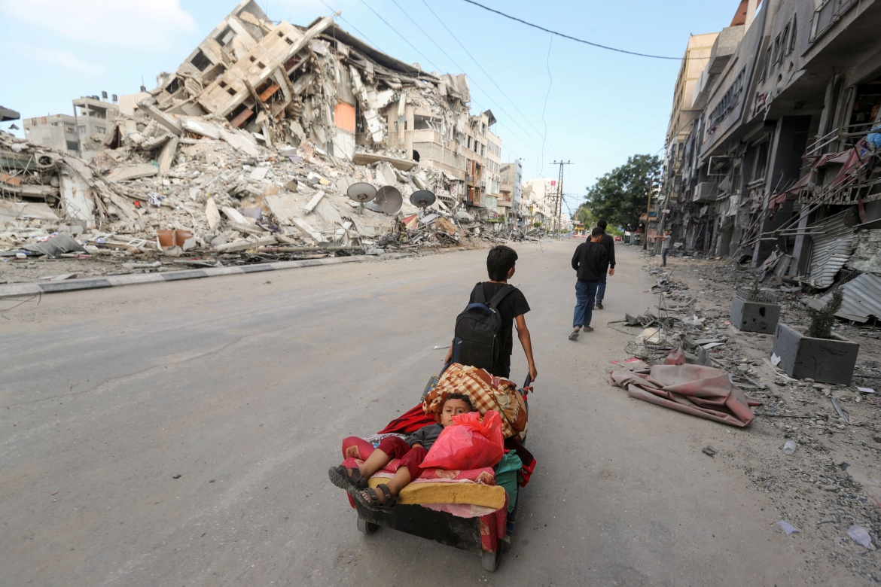

A Palestinian boy pulls a cart carrying his brother and their belongings as they flee from Israeli attacks on Gaza in 2021

**By the end of this lesson, you should be able to:**

Describe the blockade on Gaza

Explain the consequences of this

Assess the humanitarian crisis in Gaza

**Keywords**

Gaza

Blockade

Humanitarian crisis

Enclave

**Knowledge check!**

1)Have you come across any of these keywords before? Where?

2)What happened in 1967?

3)What happened to Gaza in 1967?

**Locating Gaza on the map**

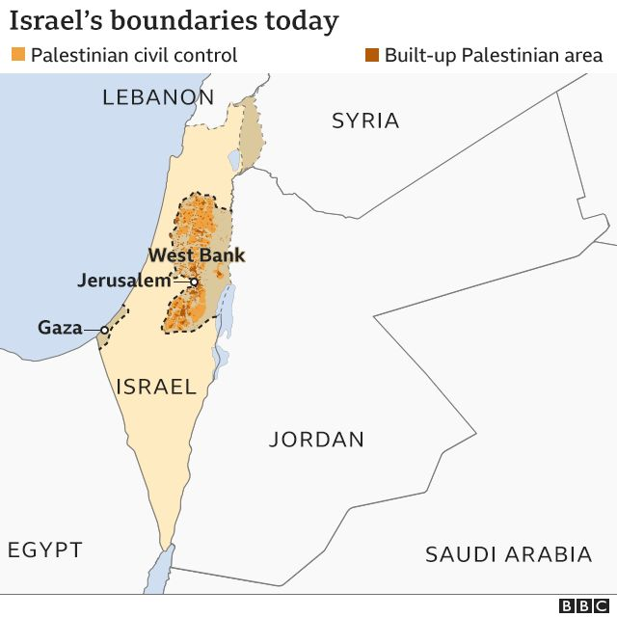

Gaza is a Palestinian **enclave** on the Mediterranean coast, which borders **Egypt** and **Israel**. An enclave is land entirely surrounded by the land or sea of another country

Another example of an enclave is the state of Vatican City, which is surrounded by Italy

**What do we already know about Gaza?**

1.Gaza is part of historic Palestine-Israel

2.After the Nakba of 1948, Gaza was controlled by Egypt

3.In 1967, Israel invaded and took control (it **occupied** Gaza)

**Hamas in Gaza**

Last lesson we looked at the 2006 Palestine election, which was won by Hamas. Fatah (Hamas’s main rival) didn’t accept the result of the election, and shortly after the election Fatah took control of the West Bank. Hamas took control of Gaza

**Did you know?**

Over 70% of Palestinians in Gaza are refugees

2 million people live in Gaza, an area of land the size of Sheffield in the UK or Lucknow in India

**Blockade**

*When land is sealed off to prevent people or goods from entering or leaving*

**The blockade of Gaza**

Since 2007, Gaza has been under blockade by Israel because of concerns about Hamas (and Israel wanting more control over Palestinian land)

This is an air, land and sea blockade. This means that **since 2007, nothing has been able to get in or out of Gaza, except a very limited amount of aid and a few people**

Some of the items not allowed into Gaza include crayons, footballs, musical instruments, wheelchairs, soap, shampoo, wood and concrete

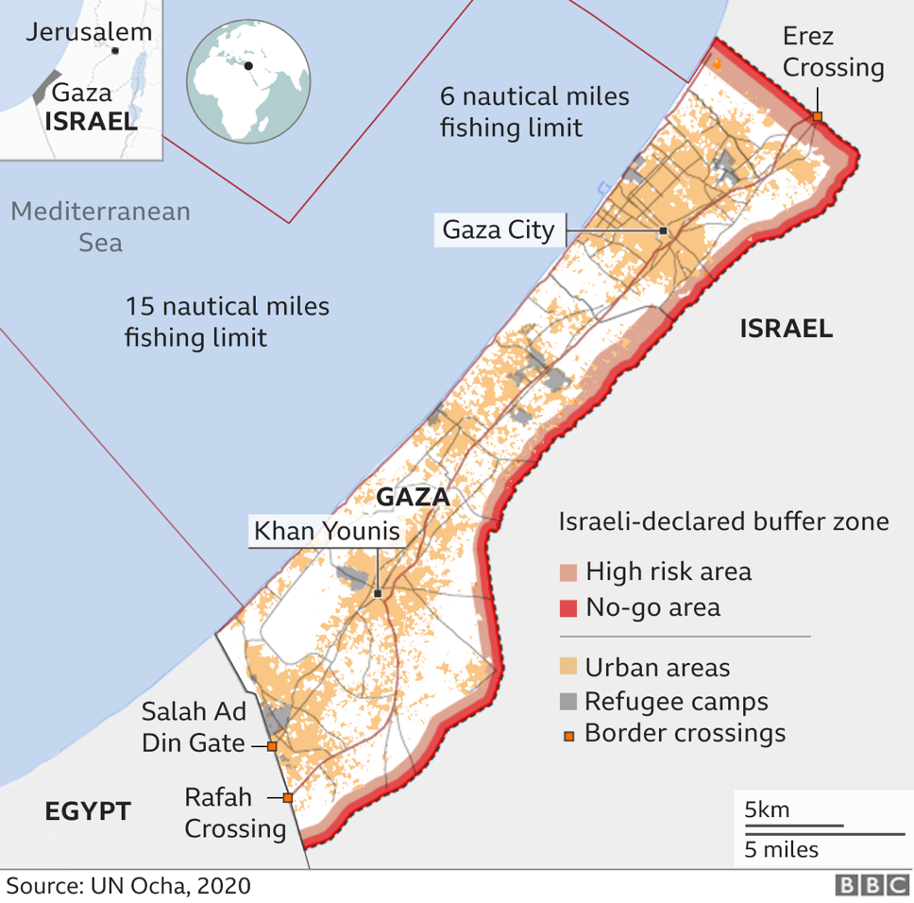

**Questions**

1.List 3 things that this map tells you about Gaza

2.How would your life be different without the objects listed above?

**Timeline of violence in Gaza**

-In the January 25th 2006 Palestine election, Hamas won. Hamas secured 44% of the vote compared to only 41% for Fatah

-Fatah did not accept the 2006 election result and kept control of the West Bank while Hamas took control of Gaza

-Israel imposed an air, land and sea blockade on Gaza in June 2007

-A 3-week armed conflict took place between Israel and Hamas from 27th December 2008 until 18th January 2009.1000 Palestinians and 13 Israelis were killed. This is known as the Gaza *Massacre or Operation Cast Lead*

-On 14th November 2012, Israel launched *Operation Pillar of Defense* on Gaza. Over 8 days, 167 Palestinians were killed, 87 of whom had not been involved in the fighting. 2 Israelis were killed

-On 8th July 2014, Israel launched *Operation Protective Edge.* Over 7 weeks of fighting, over 2000 Gazans were killed and 10,000 Gazans were wounded, including 1000 children who were left permanently disabled. 72 Israelis were killed

-In 2018 and 2019, Israeli forces unlawfully fired live ammunition at Palestinians who posed no imminent threat to life at the *Great March of Return* protests along Gaza’s border

-Between 6th and 21st May 2021, the 2021 Israel-Palestine Crisis occurred. Triggered by the forced evictions of Palestinian families from their homes in East Jerusalem, over 200 Palestinians were killed

**Questions**

How many Palestinians and how many Israelis were killed in each of the following?

a) Operation Cast Lead (also known as the Gaza Massacre)

b) Operation Pillar of Defense

c) Operation Protective Edge

**Independent activity**

If you had been born in Gaza in 2007, what would you have experienced by now?

**Photographs of life in Gaza**

What do you see in these photos?

What do they tell you about life in Gaza?

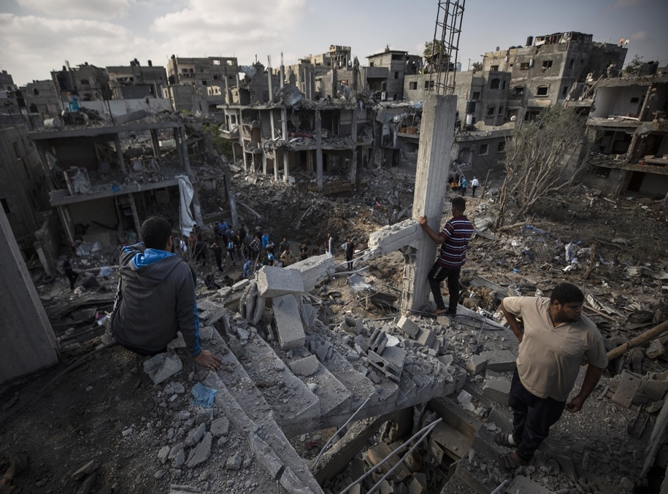 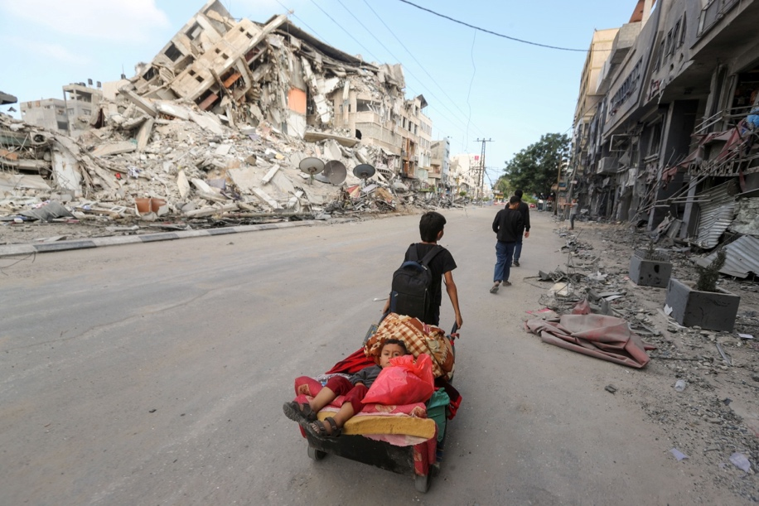 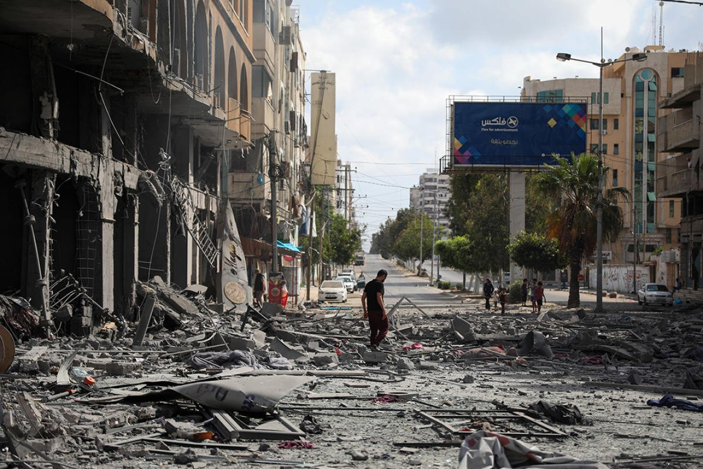

**Humanitarian crisis**

When the health, wellbeing or safety of a large group of people is seriously threatened

**Questions**

Is it possible to rebuild without wood or concrete?

**Gaza’s humanitarian crisis**

Gaza has been experiencing a humanitarian crisis for many years now, and the situation is only getting worse

Food, water, medicine and fuel are all scarce in Gaza. Nearly 80% of the population is in need of humanitarian aid and 1.3m Palestinians in Gaza do not have access to adequate safe drinking water. The unemployment rate is staggeringly high at 43%, and there is often only electricity for a few hours each day

**What do the UN and human rights groups say?**

Both the UN and leading international human rights organisations have condemned the situation in Gaza

“The scale of suffering is immense”

*-Oxfam, May 2021*

“Israeli forces have displayed a shocking disregard for the lives of Palestinian civilians”

*-Amnesty International, May 2021*

“Israel’s more than decade-long closure of Gaza severely restricts the movement of people and goods, with devastating humanitarian impact”

*-Human Rights Watch, December 2021*

“With an economy in free fall, 70 per cent youth unemployment, widely contaminated drinking water and a collapsed health care system, Gaza has become ‘unliveable’”

*-United Nations, October 2018*

Gaza has been described as “the world’s largest open-air prison”

**Activity**

Create your own statement about the situation in Gaza. It should be no longer than 3 sentences

**Activity**

Create a visual summary of what you have learned today about life in Gaza

**Exam-style question**

Explain two **consequences** of the Israeli blockade on Gaza (8 marks)